**Probability and Statistics (UCS410)**

**Experiment 1: Basics of R programming**

**(1) Create a vector c = [5,10,15,20,25,30] and write a program which returns the max-**

**imum and minimum of this vector.**

CODE:

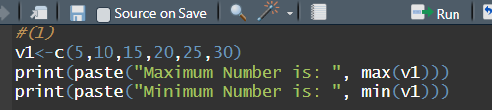

OUTPUT:

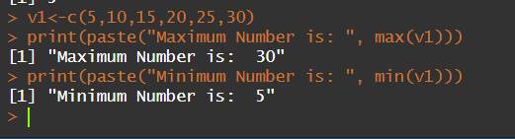

**(2) Write a program in R to find factorial of a number by taking input from user. Please**

**print error message if the input number is negative.**

CODE:

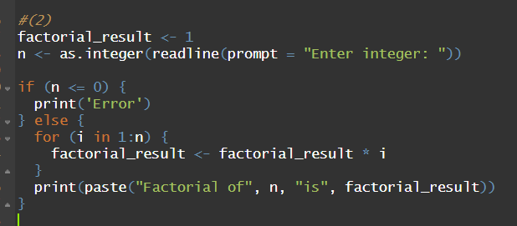

OUTPUT:

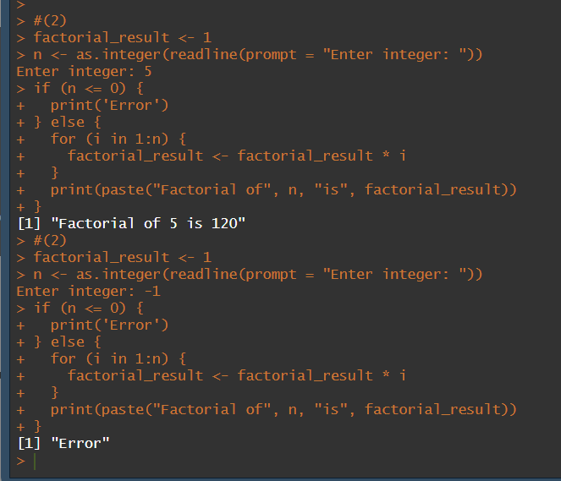

**(3) Write a program to write first n terms of a Fibonacci sequence. You may take n as an**

**input from the user.**

**CODE:**

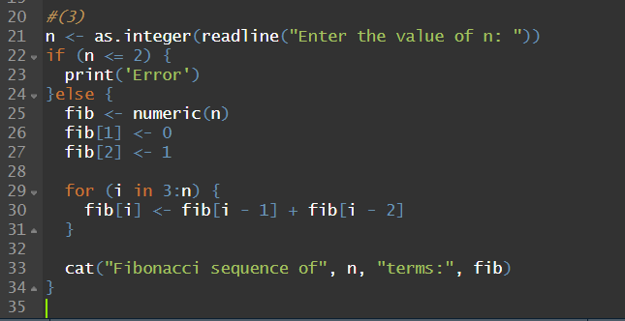

**OUTPUT:**

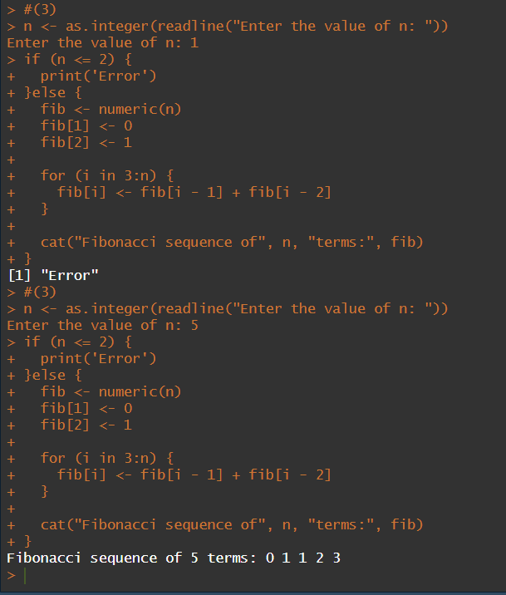

**(4) Write an R program to make a simple calculator which can add, subtract, multiply**

**and divide.**

**CODE:**

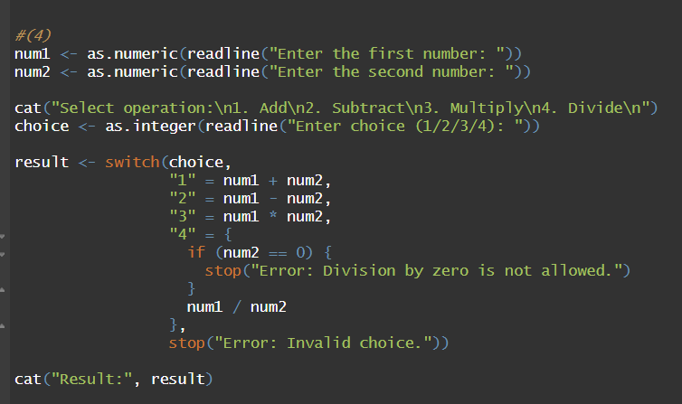

**OUTPUT:**

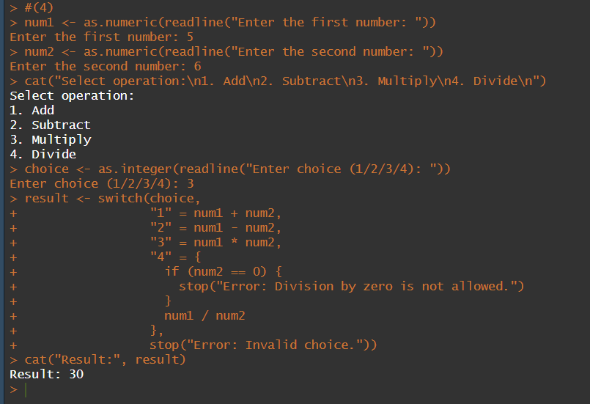

**(5) Explore plot, pie, barplot etc. (the plotting options) which are built-in functions in R.**

**CODE:**

**PIE CHART:**

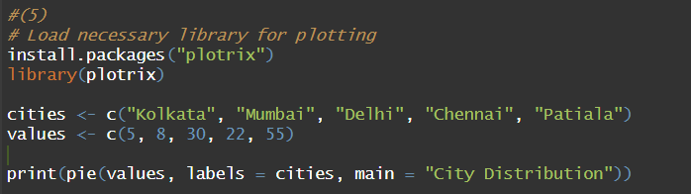

**BAR GRAPH:**



**HISTOGRAM:**



**SCATTER PLOT:**

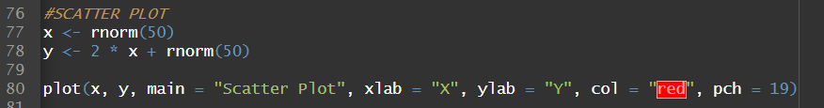

**LINE PLOT:**

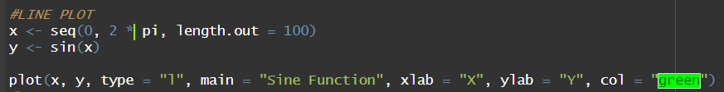

**BOX PLOT:**



**OUTPUT:**

**PIE CHART:**

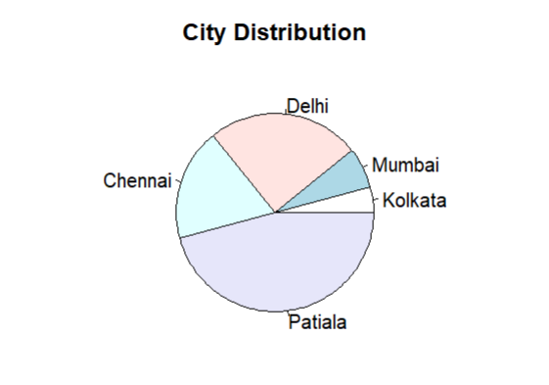

**BAR GRAPH:**



**HISTOGRAM:**

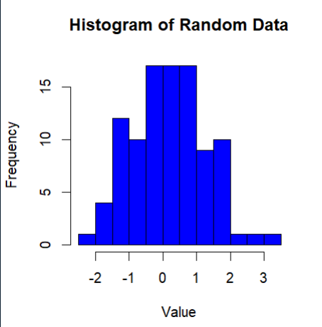

**SCATTER PLOT:**

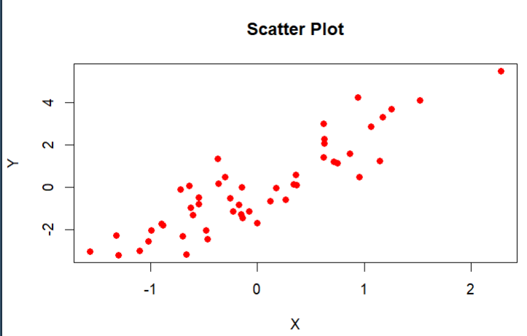

**LINE PLOT:**

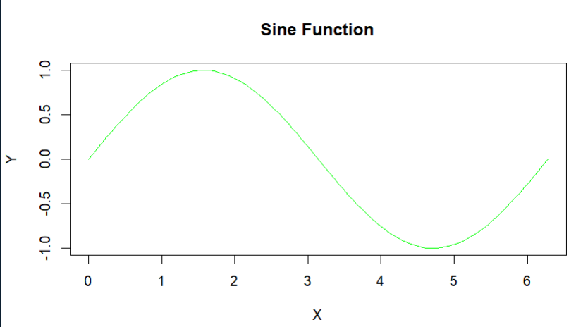

**BOX PLOT:**

